Technology Stack (Architecture & Stack)

|  |  |
| --- | --- |
| Date | 17 OCTOBER 2022 |
| Team ID | PNT2022TMID47580 |
| Project Name | Smart Solution Railways |
| Project Marks | 4 Marks |

**Technical Architecture:**

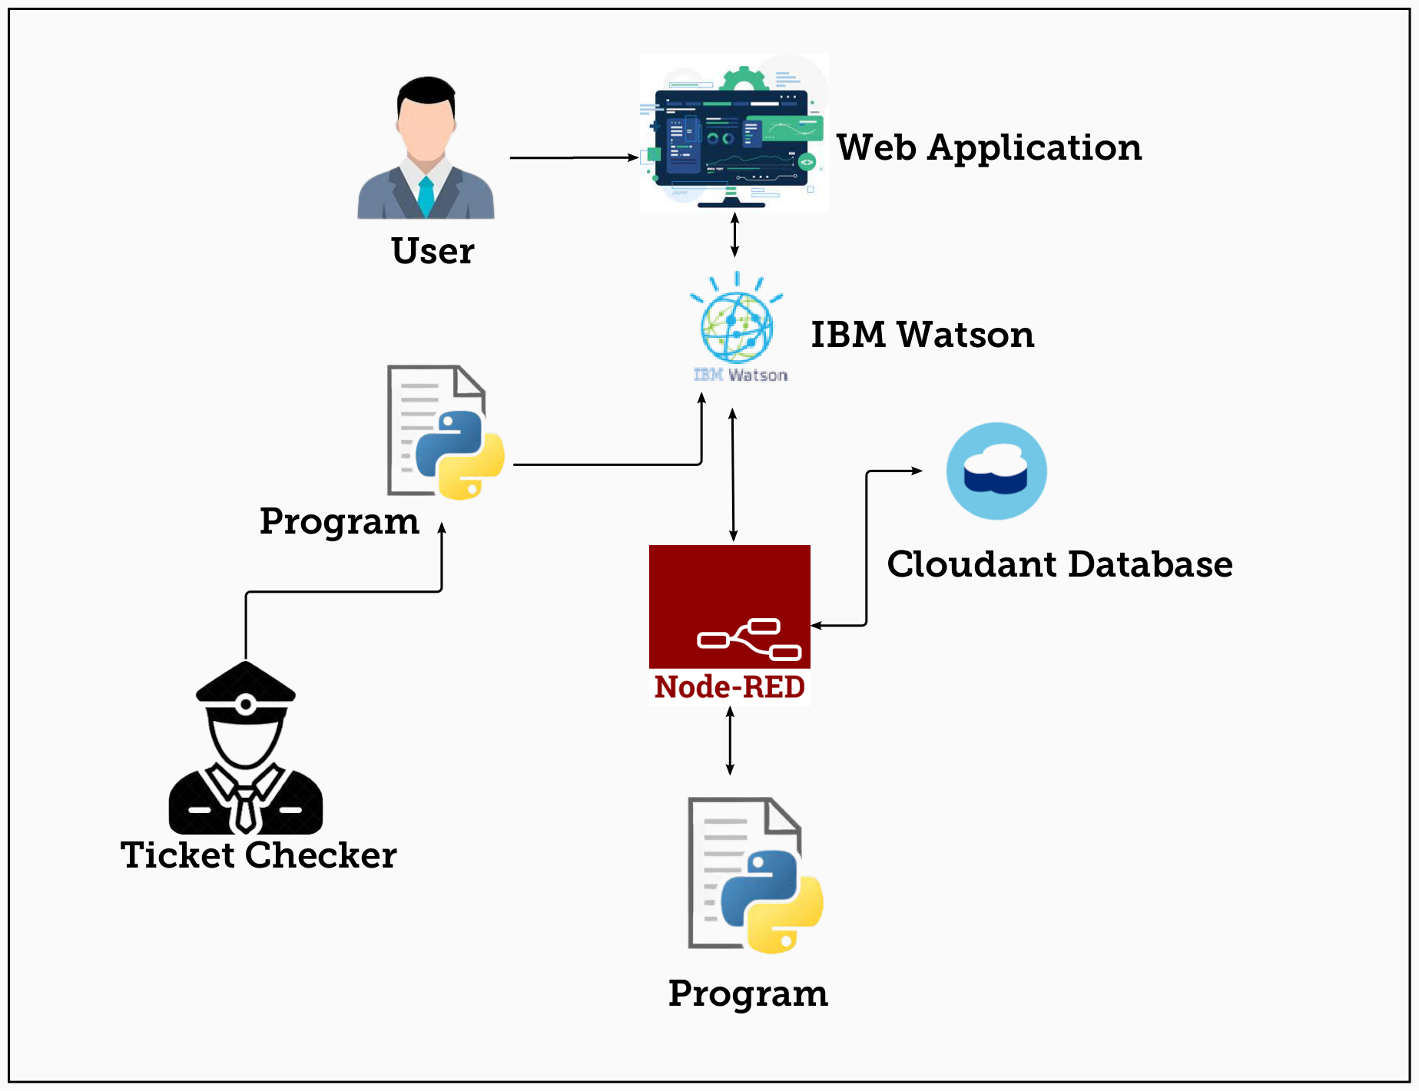

**Table : Components & Technologies:**

|  |  |  |  |
| --- | --- | --- | --- |
| **S.No** | **Component** | **Description** | **Technology** |
| 1. | User interface | Web & Mobile Application | Node red UI and MIT App Inventor |
| 2. | Application logic-1 | Sending Random Latitude and Longitude for the train location tracking. | Python |
| 3. | Application Logic-2 | Generating QR Code which holds the unique ID. | Node RED. |
| 4. | Database | Data Type, Configurations etc. | MySQL & Maria Database |
| 5. | Cloud Database | Database Service on Cloud | IBM Cloudant |
| 6. | File Storage | File storage requirements | IBM Block Storage |
| 7. | External API-1 | To show the current location of the Train using the map api. | World Map API |
| 8. | External API-2 | Used to send the Email for the user which is used for the verification. | Email Sending API, |
| 9. | Infrastructure (Server / Cloud) | Application Deployment on Server. | Kubernetes. |

**Table-2: Application Characteristics:**

|  |  |  |  |
| --- | --- | --- | --- |
| **S.No** | **Component** | **Description** | **Technology** |
| 1. | Open-Source Frameworks | MIT App Inventor, Flask | Block Based Programming Language, python |
| 2. | Security Implementation | User Details and Entered Data will be Encrypted. | Industry-Standard AES-256 encryption |
| 3. | Scalable Architecture | The Scanner code written are highly scalable where any implementation or modifications can be done when ever it required. | Python. |
| 4. | Availability | As 90% of the process is done by Cloud service, The Application is available at any time required. | IBM Cloud Service & IBM Load Balancer |
| 5. | Performance | Thus The Process are complete done through Cloud Service and the Data’s are stored in IBM Cloudant Database, the Performance of this project is high. | IBM Cloud Service, IBM Cloudant Database and Distributed Service. |